In Singapore, the Primary School Leaving Examinations (PSLEs) are taken by most students near the end of their sixth year. Until 2020, performance on the PSLEs was reported as T-scores. But what are T-scores? Here is the Straits Times' explanation:

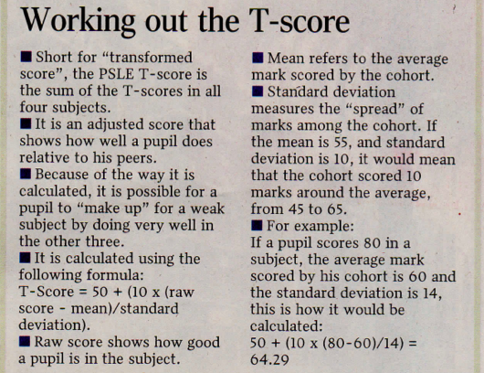

*Amelia Teng, Grade system means 'one subject can't save another', The Straits Times, 24 August 2013*

1) Do you see any *innumeracy* in the explanations above? That is, do you see bad reasoning or explanations that involve numbers?

2) The formula for an individual subject T-score above is correct. For each subject, what is the expected mean and standard deviation of the raw scores? Of the T-scores?

3) What is the relationship of a z-score and an individual subject T-score?

4) An MOE publication claims that "Statistically, the Average National Aggregate T-score should be 200." Is this true? If not, provide a counter-example.

5) The MOE publication goes on to state that "Many parents believe that the maximum aggregate is 300." Is this the maximum score? If not, what is it?

6) Finally, the MOE publication claims that it is "not accurate to compare a student's aggregate score in a particular year to the aggregate score of another student in a different year." Is this true? Why or why not?

7) In a previous year, there was a request in parliament that included the following: "[W]ill the Ministry consider releasing the raw scores for greater transparency so that parents can make more informed decisions on their children’s education?" What do you think of this request?

8) Since 2020, PSLE scores have been reported as grade bands, akin to the marks for O-levels and A-levels. Do you think this system is better? What problems does it try to solve? And does it solve them?